ReactJS Hands-On Lab 5 - Output Report

Objective
Style React components using CSS Modules and inline styles to display a dashboard of ongoing and completed cohorts.

Environment Setup & Project Creation
Downloaded and built the React application, restored node packages, and verified project creation:
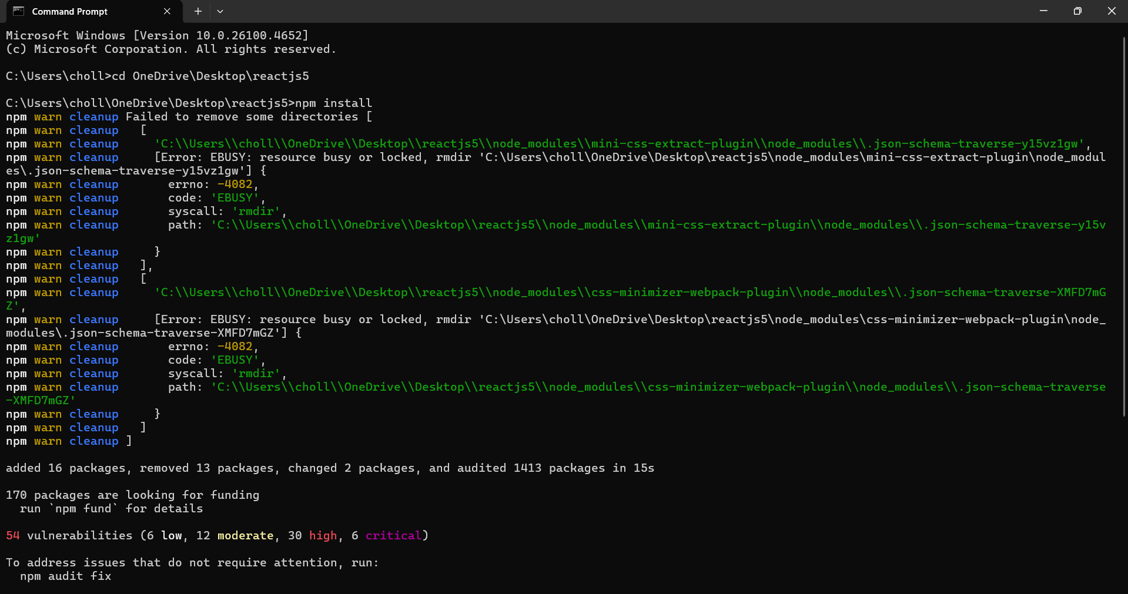

Project in VS Code
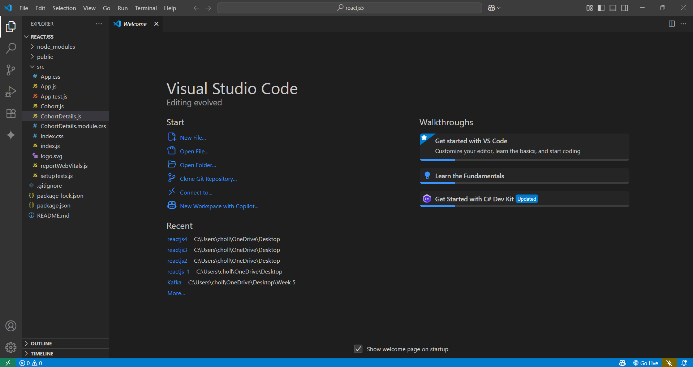

Components & Styling
Implemented CohortDetails component with CSS Modules and inline styling. Applied conditional styles based on cohort status:
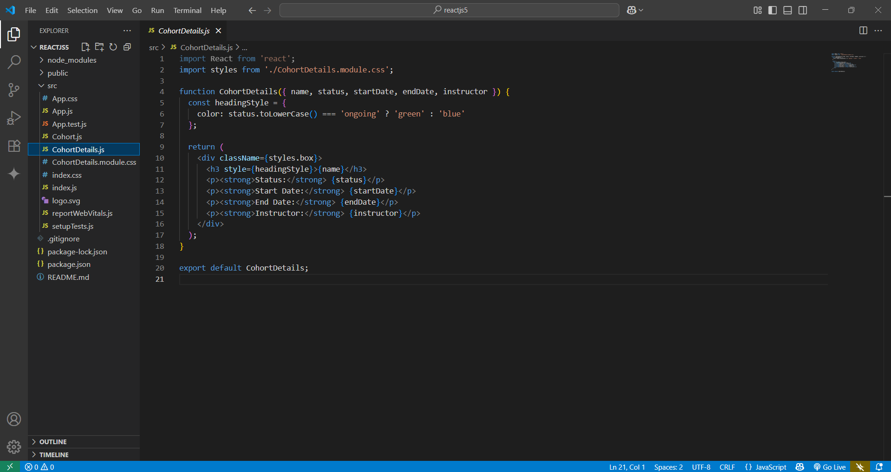
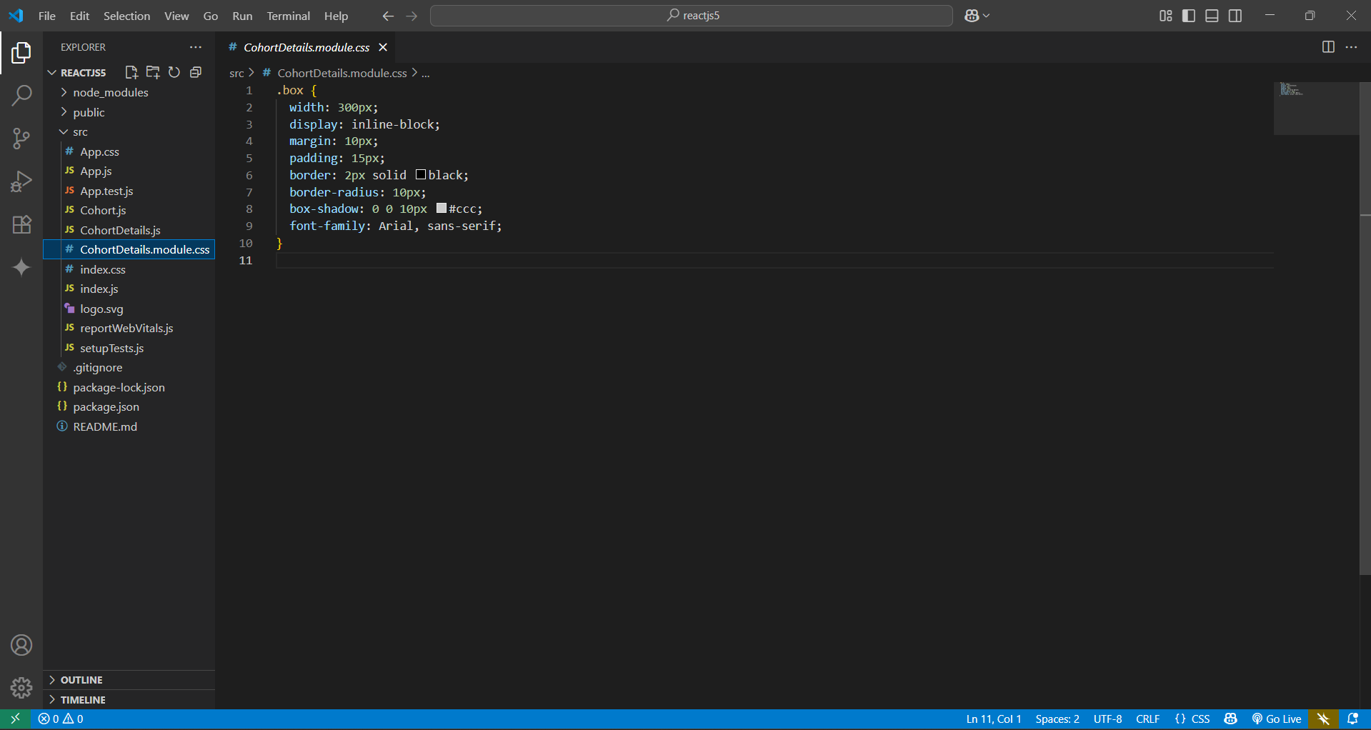

Edited App.js
Added CohortDetails components in App.js to display cohort details:
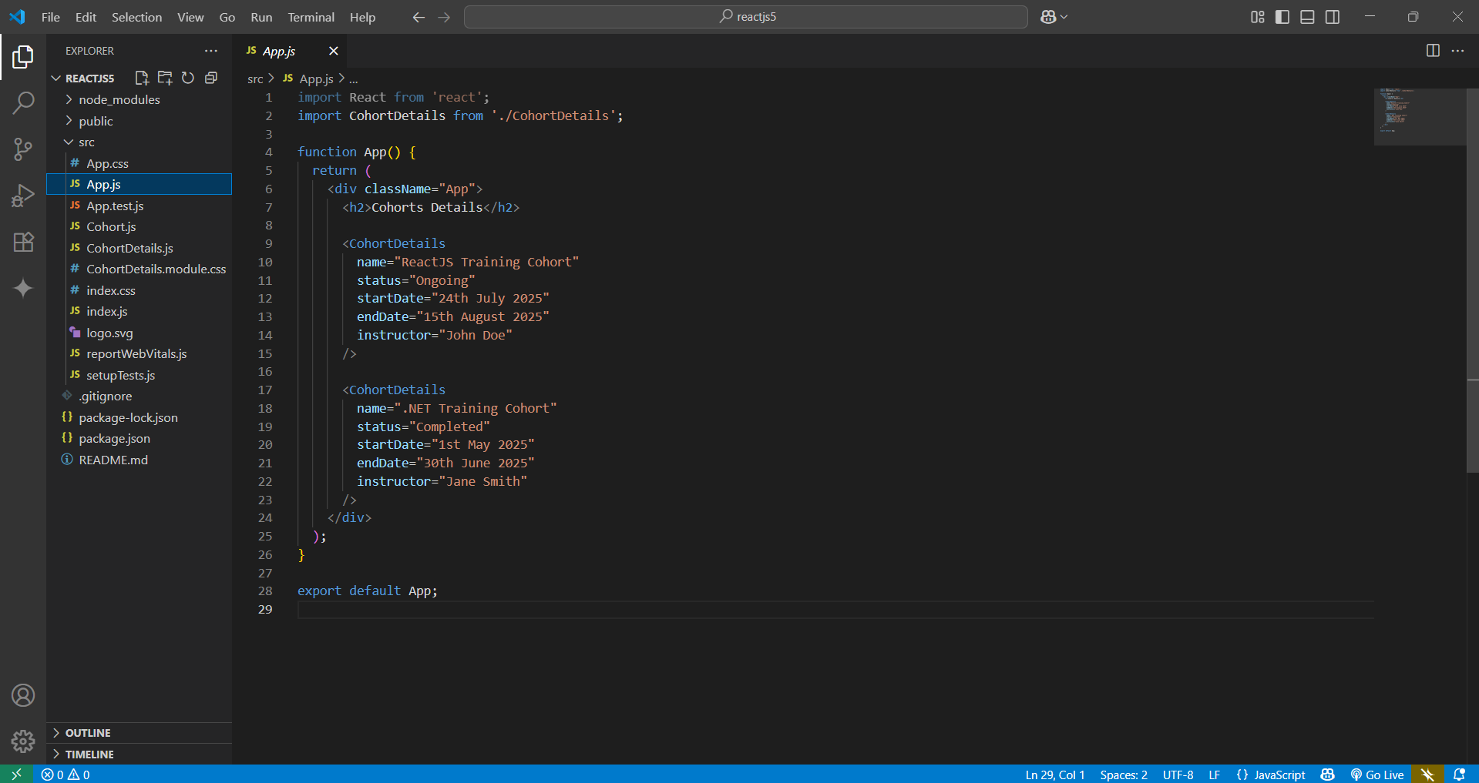

Webpack Compilation
Started the development server and verified successful compilation:
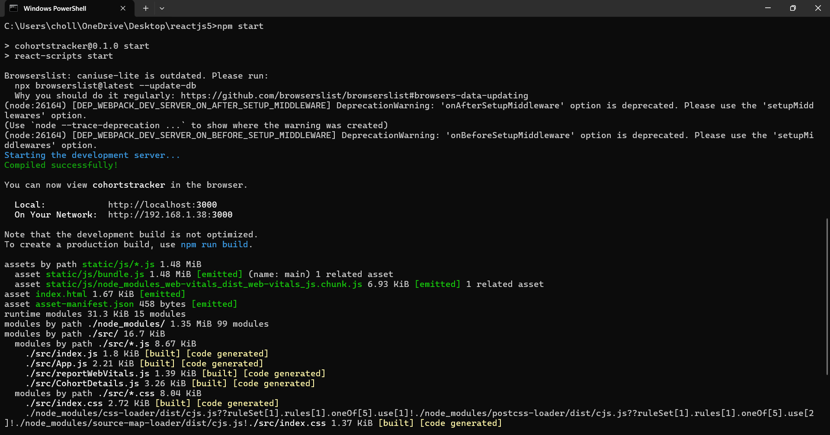

Browser Output
Verified that the React app displays styled cohort details with correct colors for statuses in the browser:
